A flip flop is an electronic circuit with two stable states that can be used to store binary data. The stored data can be changed by applying varying inputs. Flip-flops and latches are fundamental building blocks of digital electronics systems used in computers, communications, and many other types of systems. Flip-flops and latches are used as [data storage](https://electronicsforu.com/technology-trends/latest-storage-products) elements. It is the basic storage element in sequential logic. But first, let’s clarify the difference between a latch and a flip-flop.

For example, let us talk about SR latch and SR flip-flops. In this circuit when you Set S as active the output Q would be high and Q’ will be low. This is irrespective of anything else. (This is an active-low circuit so active here means low, but for an active high circuit active would mean high)

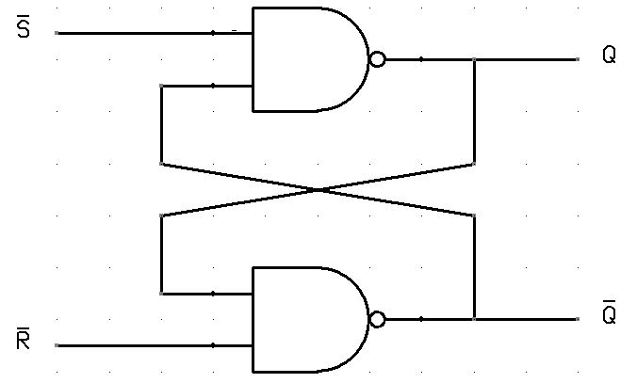

**There are basically four different types of flip flops and these are:**

* Set-Reset (SR) **flip**-**flop** or Latch.
* JK **flip**-**flop**.
* D (Data or Delay) **flip**-**flop**.
* T (Toggle) **flip**-**flop**.

**Difference between Flip-flop and Latch :**

|  |  |  |
| --- | --- | --- |
| **SNO** | **FLIP-FLOP** | **LATCH** |
| 1 | Flip-flop is a bistable device i.e., it has two stable states that are represented as 0 and 1. | Latch is also a bistable device whose states are also represented as 0 and 1. |
| 2 | It checks the inputs but changes the output only at times defined by the clock signal or any other control signal. | It checks the inputs continuously and responds to the changes in inputs immediately. |
| 3 | It is a edge triggered device. | It is a level triggered device. |
| 4 | Gates like NOR, NOT, AND, NAND are building blocks of flip flops. | These are also made up of gates. |
| 5 | They are classified into asynchronous or synchronous flipflops. | There is no such classification in latches. |
| 6 | It forms the building blocks of many sequential circuits like counters. | These can be used for the designing of sequential circuits but are not generally preferred. |
| 7 | a, Flip-flop always have a clock signal | latche doesn’t have a clock signal |
| 8 | Flip-flop can be build from Latches | Latches can’t build from gates |
| 9 | ex:D Flip-flop, JK Flip-flop | ex:SR Latch, D Latch |

Counter is a sequential circuit. A digital circuit which is used for a counting pulses is known counter. Counter is the widest application of flip-flops. It is a group of flip-flops with a clock signal applied. Counters are of two types.

* Asynchronous or ripple counters.
* Synchronous counters.

Asynchronous or ripple counters

The logic diagram of a 2-bit ripple up counter is shown in figure. The toggle (T) flip-flop are being used. But we can use the JK flip-flop also with J and K connected permanently to logic 1. External clock is applied to the clock input of flip-flop A and QA output is applied to the clock input of the next flip-flop i.e. FF-B.

Logical Diagram

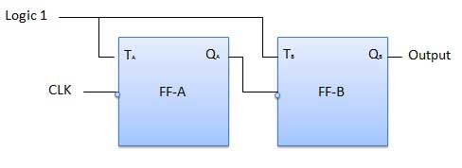

## Synchronous counters

If the "clock" pulses are applied to all the flip-flops in a counter simultaneously, then such a counter is called as synchronous counter.

### 2-bit Synchronous up counter

The JA and KA inputs of FF-A are tied to logic 1. So FF-A will work as a toggle flip-flop. The JB and KB inputs are connected to QA.

### Logical Diagram

